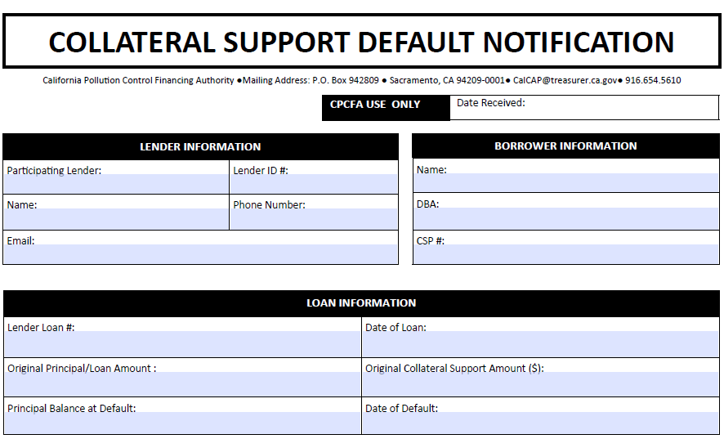 § 8078.33 (b) & (c)
(b) For a loan in default, the Participating Financial Institution shall provide in each Quarterly Report a short report of the status of the loan, including a short narrative of the loan collection history, and the status of the attempt to work out the default including the sale of proceeds or attempts to liquidate collateral.
(c) If the default or delinquency affecting the Qualifying Loan is subsequently resolved through a Change in Terms, settlement or other workout which avoids charge-off and collateral liquidation of the loan, the Participating Financial Institution shall promptly withdraw the Default Notification, and the Annual Recapture will resume according to the original schedule and loan anniversary date.

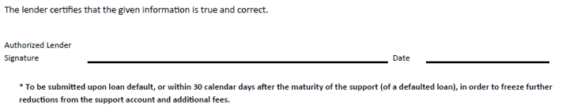

Revised 8/15/2017

